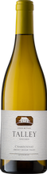
Talley Chardonnay 2013 Vintage – 3 Bottles – Citrus notes of lemon curd and lime zest characterize this refreshing medium-bodied chardonnay. This delicious wine is handcrafted in the Arroyo Grande Valley in California. Value: $100
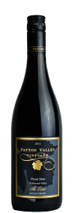
Patton Valley Pinot Noir 2013 Vintage – 3 bottles –
A pure expression of Pinot Noir, this wine is powerful and reserved with blackberry, crème brûlée, bergamot, cherry stone. Handcrafted in a small winery in the Willamette Valley, Oregon
Value: $100

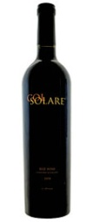
Col Solare 2005 vintage– one bottle - A joint venture wine between the Antinori family of Italy and Chateau Ste. Michelle in Washington – made at a winery in the Red Mountain Area of Washington. Aromas of black cherry, berry and dark chocolate fuse with smooth notes of vanilla and spice. Rich and balanced on the palate, this wine finishes with long, lingering flavors of cocoa, black fruits, and vanilla.
Value: $80

Col Solare 2006 vintage– one bottle - A joint venture wine between the Antinori family of Italy and Chateau Ste. Michelle in Washington – made at a winery in the Red Mountain Area of Washington. Aromas of black cherry, berry and dark chocolate fuse with smooth notes of vanilla and spice. Rich and balanced on the palate, this wine finishes with long, lingering flavors of cocoa, black fruits, and vanilla.
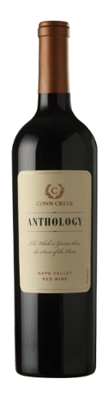
Value: $80

Conn Creek Anthology – 2010 Vintage – one bottle – A beautiful Napa Valley Cabernet from California - Blackberries and plums nestle among cocoa, anise and wildflowers. On the palate a bright opening of black currants leads to a lingering finish of rich chocolaty tannins. Value: $150
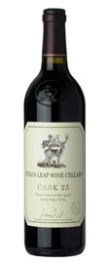
Stags Leap Cask Selection – 2009 Vintage – one bottle - Napa Valley Premier Estate Vineyard wine from California. Wine expert Robert Parker says of this wine, “it is dark, rich, and intensely satisfying. Layers of dark fruit flow effortlessly from this big, textured Cabernet Sauvignon. The 2009 possesses gorgeous mid-palate depth and stunning overall balance. This is a super-impressive showing.” Value: $225
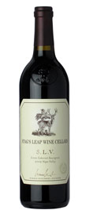
Stags Leap SLV Vineyard 2009 Vintage – one bottle A Napa Valley Premier Estate vineyard from California. Rich and inviting, this Cabernet Sauvignon offers powerful blackberry and black cherry aromas with hints of cigar box and spice. The black fruit carries over onto the palate and is accented by notes of anise, mandarin orange, violets and cassis. The tannins are smooth and fine-grained, allowing the wine to flow smoothly across the palate. The wine has great acidity and a persistent fruit-driven finish. Value: $150
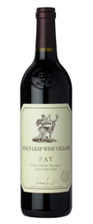
Stag’s Leap Fay Vineyard 2009 vintage one bottle – A Napa Valley Premier Estate vineyard from California. This delicious 100% Cabernet is supple and generous. The tannins are gentle, the acidity soft yet supportive of the structure, and as for the flavors, they go beyond satisfaction to sheer delight. They include blackberry, cherry, blueberry, currant, mocha and red licorice, but the wine has an earthiness that give it true complexity. Value: $150

